AUTOMATED NETWORK REQUEST
MANAGEMENT SYSTEM
Project Documentation

Platform: ServiceNow • Service Catalog • Flow Designer

Prepared by
Suravarapu Durga Prasad

Individual Project

Document Information
Item | Details
Project title | Automated Network Request Management System
Platform | ServiceNow Personal Developer Instance (PDI)
Application approach | ServiceNow-native configuration; no separate React/Node.js/MongoDB application
Developer | Suravarapu Durga Prasad
Project type | Individual project
Primary components | Service Catalog, catalog variables and variable set, custom table, Flow Designer, approvals, catalog tasks, UI Policy, notifications

Contents
- 1. Introduction
- 2. Problem Statement and Objectives
- 3. Project Overview and Functional Scope
- 4. ServiceNow Architecture and Design
- 5. Implementation Details
- 6. Request Lifecycle and Workflow Logic
- 7. Data Model and Field Mapping
- 8. Setup and Reproduction Guide
- 9. Testing and Troubleshooting
- 10. Screenshots and Evidence
- 11. Benefits and Client Value
- 12. Limitations and Known Considerations
- 13. Future Enhancements
- 14. Conclusion

1. Introduction
The Automated Network Request Management System is a ServiceNow-based workflow solution designed to make the submission, review, approval, tracking, and communication of network-related service requests more consistent. It provides a structured Network Request item in the Service Catalog and uses Flow Designer to create a corresponding custom-table record, send a confirmation email, request approval, and update the record according to the approval outcome.
The project is implemented inside ServiceNow. It does not use a separate React frontend, Node.js/Express backend, or MongoDB database. The user-facing request form is the ServiceNow Service Catalog/Service Portal interface; data is stored in ServiceNow tables; and process automation is configured using ServiceNow Flow Designer and related platform configuration.

1.1 Purpose of this document
This document explains the operational problem, the solution implemented on ServiceNow, the configuration components, the request lifecycle, the supporting screenshots, how the solution can be recreated in a Personal Developer Instance, and the value it can provide to an IT operations team.

2. Problem Statement and Objectives

2.1 Existing problem
In a manual network-request process, users may submit incomplete requests through email, chat, or informal channels. Teams can spend time clarifying information, forwarding requests to the right approver, creating work items, notifying requesters, and checking the latest status. When these activities are handled separately, requests can be delayed, ownership can be unclear, and the history of decisions may be difficult to audit.
The core problem addressed by this project is the lack of a single, structured and automated process for capturing network requests and coordinating their approval and fulfillment.

2.2 Project objectives
- Provide one Service Catalog entry point for submitting a Network Request.
- Capture request information using defined catalog variables and a reusable variable set.
- Create a structured record in a custom ServiceNow table from submitted catalog data.
- Trigger an email confirmation so that the request submission is communicated to the relevant recipient.
- Route the created record through an approval step in Flow Designer.
- Update the custom record based on the approval result, so that the outcome is recorded centrally.
- Use a Catalog UI Policy to control the visibility of the existing-ID field when the connection type is Existing.
- Use ServiceNow request, approval, and task records to support traceability and operational follow-up.

2.3 Scope and accuracy note
The screenshots supplied for this document directly demonstrate the Network Request catalog item, its variables and variable set, the custom database table and fields, the active Flow Designer sequence, approval records, request summary, and confirmation email. The broader project description also identifies group/role configuration, task assignment, SLA monitoring, dashboards, and detailed status progression as intended capabilities. These should be described as implemented only where the corresponding configuration has been completed and verified in the instance; this document does not assume unshown ACL, SLA, dashboard, or group-routing configuration.

3. Project Overview and Functional Scope

3.1 Functional overview
A requester opens the ServiceNow Service Catalog and selects the Network Request item. The form captures user and request details. On submission, ServiceNow creates the standard request/requested-item records and starts the active Network Request flow. The flow retrieves the catalog variables, creates a record in the custom Database Table, sends a notification email, and asks for approval. An If/Else condition checks the approval result and runs the corresponding update-record action.

3.2 Main features
Feature | Purpose | Evidence in supplied screenshots
Network Request catalog item | Provides a consistent form and catalog entry point. | Catalog item configuration and Service Portal form
Catalog variables | Captures requester details and request-specific information. | Seven variables listed on the catalog item
Reusable variable set | Groups common user details together for consistent form design. | Network Request User Details variable set
Conditional field visibility | Shows the existing-ID field when connection type is Existing. | Active Catalog UI Policy and condition
Custom table | Stores a structured network request record and its approval status. | Database Table dictionary and record form
Flow Designer automation | Coordinates variable retrieval, record creation, email, approval and record update. | Active Network Request flow
Approval record | Maintains the approval state and approver information. | Approval related list showing Approved state
Email notification | Confirms receipt and provides request reference information. | Email record and rendered email preview
Request summary | Lets the requester see the request number, delivery estimate, item, and stage. | Request Summary screen

3.3 Roles in the process
Role | Responsibility
Requester | Submits the Network Request and uses the request reference to follow progress.
Approver | Reviews the request and approves or rejects it through the ServiceNow approval process.
Fulfillment / network team | Reviews assigned work and completes the requested network activity, according to the configured operational process.
ServiceNow administrator / developer | Maintains catalog configuration, variables, custom table fields, flow logic, access configuration, and notification settings.

The exact assignment groups and approval-routing rules should match the configuration in the target instance. The documented flow screenshot proves an approval action and an approval-result condition; it does not, by itself, prove every proposed manager, security, or department-specific routing rule.

4. ServiceNow Architecture and Design

4.1 Platform architecture
Layer | ServiceNow component | Responsibility
User interaction | Service Catalog / Service Portal | Displays the Network Request form and accepts user input.
Form behavior | Catalog variables, variable set, Catalog UI Policy | Collects values and changes field visibility based on connection type.
Workflow orchestration | Flow Designer | Runs the catalog-triggered automation and approval decision.
Data storage | Custom table: u_database_table (label: Database Table) | Stores mapped request details and approval status.
Request tracking | Service Catalog request and requested-item records | Tracks the submitted catalog request, item, stage, and related fulfillment records.
Approval tracking | ServiceNow approval records | Records the approver and approval state.
Communication | Flow Designer Send Email action / ServiceNow email notification infrastructure | Sends a request confirmation message.

This is a platform-native design. There is no separately deployed client/server application. ServiceNow provides the form interface, database, workflow execution, approval records, and notification mechanism.

4.2 High-level workflow
Requester submits catalog item
↓
Service Catalog trigger starts Network Request flow
↓
Get Catalog Variables → Create Database Table Record
↓
Send Email → Ask for Approval
↓
If approval is Approved: update custom record
Else: update custom record with the alternate outcome
Figure 1. Logical sequence derived from the active Flow Designer configuration shown in the screenshots.

5. Implementation Details

5.1 Network Request catalog item
A catalog item named Network Request was created under the Network and Connectivity category in the Service Catalog. The item is active and has the short description “Network Service Request.” It is the primary entry point for the user to submit a network-related request.
The supplied catalog configuration shows seven variables:
Variable / question | Type shown | Purpose
Requested For | Single Line Text | Identifies the person for whom the request is raised.
Mobile Number | Single Line Text | Captures a contact number.
Type of Connection | Multiple Choice | Distinguishes a new connection from an existing connection.
Enter your existing id | Single Line Text | Captures an existing identifier when applicable.
Total Amount | Single Line Text | Captures the amount associated with the request.
Mode of Payment | Multiple Choice | Captures the selected payment method.
Address | Multi Line Text | Captures the relevant address or location details.

The form also includes a variable set named Network Request User Details with Opened on Behalf of, Email ID, User Name, and Phone Number. Reusing these common fields keeps the user-detail section grouped and easier to maintain.

5.2 Dynamic form behavior using Catalog UI Policy
An active Catalog UI Policy named “visible/hide of ID field” is configured for the Network Request catalog item. Its condition checks whether type_of_connection is Existing. The related UI Policy Action makes the enter_your_existing_id field visible. The screenshot also shows that the policy applies to the catalog item view and catalog tasks, runs on load, and reverses the effect when the condition becomes false.
This behavior avoids asking users to provide an existing identifier when they are requesting a new connection, while allowing the field to appear when it is relevant. The supplied configuration demonstrates this field-visibility rule; it should not be interpreted as proof of additional validation rules unless those are separately configured.

5.3 Custom Database Table
A custom table is configured with the label Database Table and internal name u_database_table. The visible record form contains fields for Database Number, Mobile Number, Total Amount, Address, Mode of Payment, Requested For, Type of Connection, Assigned to, and Approval Status. The Database Number field uses a default value expression for generating a padded sequential identifier.
Field | Observed type / behavior | Purpose
Database Number | String; default value expression shown | Readable identifier for a stored network request record.
Assigned to | Reference to User | Identifies the user responsible for handling the record.
Mobile Number | String | Stores the submitted contact number.
Total Amount | String | Stores the amount entered in the form.
Approval Status | String | Stores the current approval outcome/status.
Address | String | Stores the request address.
Mode of Payment | String | Stores the selected payment mode.
Requested For | String | Stores the person associated with the request.
Type of Connection | String | Stores New or Existing selection.
System fields | Sys ID, Created, Created by, Updated, Updated by, Updates | Provides standard ServiceNow record identity and audit metadata.

The Flow Designer Create Database Table Record action maps catalog variable values into this table. The Update Database Table Record actions then update the stored record after the approval branch is evaluated.

5.4 Flow Designer automation
The active flow is named Network Request and uses a Service Catalog trigger. The screenshot shows the following ordered actions and branch logic:
- Trigger — Service Catalog: starts the flow when the catalog request is submitted.
- Get Catalog Variables from Network Request: retrieves values entered in the catalog item and makes them available to later actions.
- Create Database Table Record: creates a row in the custom Database Table using the request values.
- Send Email: sends a request-created confirmation message.
- Ask For Approval on Database Table: starts the approval step for the created record.
- If approval state is Approved: runs Update Database Table Record on the approved branch.
- Else: runs a second Update Database Table Record action for the non-approved branch.
This configuration keeps the core process in Flow Designer rather than requiring a separate application server. The flow screenshot confirms the action sequence and the If/Else check. The exact field values set by each update action should be validated in the instance before describing the rejected branch as “Rejected,” “Cancelled,” or another specific state.

5.5 Approval tracking
The supplied custom-table record screenshot shows an Approval Request related list with an approval in the Approved state and System Administrator as the approver. This demonstrates that an approval record is available alongside the custom network request record. Keeping the approval associated with the request helps administrators review the decision and its recorded state.

5.6 Email notification
The email evidence shows a message with the subject “Request REQ0010003 was created.” The rendered message says that the request was received, includes the request reference, and provides a View request link. It also shows the requested item number, short description “Network Request,” and quantity. This is a user-facing confirmation that the submission has entered ServiceNow.
The screenshot of the email record shows admin@example.com as the recipient for the demonstrated test. In a production implementation, recipients should be dynamically derived from the requester or operational notification requirements rather than left as a test address.

5.7 Request and fulfillment records
The Request Summary screen shows request number REQ0010003, the Network Request item, an estimated delivery date, and the current stage “Assess or Scope Task.” A related Requested Item screen also shows catalog tasks such as “Assess or Scope Task” and “Provide requested service.” These are standard Service Catalog fulfillment records that help track the work associated with the request.

6. Request Lifecycle and Workflow Logic
Step | System behavior | Result
1. Submit | User completes and submits the Network Request catalog item. | ServiceNow creates request and requested-item records.
2. Retrieve input | Flow Designer reads catalog variables. | Submitted values are available to automation actions.
3. Create record | Flow creates a row in u_database_table. | Request data is stored in a structured custom table.
4. Notify | Send Email action sends the configured confirmation. | Requester or configured recipient receives a reference to the request.
5. Request approval | Ask For Approval action initiates the approval step. | Approval state and approver information can be recorded.
6. Evaluate result | If/Else condition checks whether the approval state is Approved. | Flow selects the corresponding branch.
7. Update record | The chosen branch runs Update Database Table Record. | The custom record is updated based on the approval result.
8. Fulfillment tracking | ServiceNow request, requested-item, and catalog-task records track fulfillment progress. | Operators can review stage and associated tasks.

6.1 Example scenario
A user submits a request for a new or existing network connection. ServiceNow records the catalog submission and starts the flow. The flow copies the submitted details into the custom table and sends a confirmation. An approver reviews the request. If the approval state is Approved, the flow executes the approved update path; otherwise, it executes the alternate path. The requester and support team can refer to the request number and associated records when following up.

7. Data Model and Field Mapping
The project uses ServiceNow’s built-in Service Catalog records alongside the custom table u_database_table. The built-in request records represent the catalog transaction and its fulfillment lifecycle; the custom table provides the project-specific view of network-request data and approval status.
Source | Target field (custom table) | Mapping purpose
Catalog variable: requested_for | Requested For | Copies the selected/requested person.
Catalog variable: mobile_number | Mobile Number | Copies the submitted mobile number.
Catalog variable: type_of_connection | Type of Connection | Copies the New/Existing choice.
Catalog variable: total_amount | Total Amount | Copies the entered amount.
Catalog variable: mode_of_payment | Mode of Payment | Copies the selected payment method.
Catalog variable: address | Address | Copies the address/location details.
System-generated value | Database Number | Creates a readable identifier for the custom record.
Approval action result | Approval Status | Records the workflow outcome using the configured update action.
ServiceNow user reference | Assigned to | Identifies the record owner when assignment is configured.

This table describes the intended mapping based on the visible variables, custom-table fields, and flow actions. Before using the document as a configuration handoff, confirm each field-to-field data pill mapping inside the Create/Update Record actions because the screenshots do not expose every action’s detailed field mapping.

8. Setup and Reproduction Guide
The following procedure describes how an administrator or developer could recreate the documented solution in a ServiceNow Personal Developer Instance. Menu labels can vary slightly by ServiceNow release and interface.

8.1 Prerequisites
- A ServiceNow Personal Developer Instance with permission to create catalog items, custom tables, catalog variables, UI policies, and flows.
- A user account with appropriate administrator/developer access in the instance.
- Access to Service Catalog, Flow Designer, System Definition / Tables, and email logs.
- A test requester and test approver account, plus a safe test email recipient.

8.2 Configuration sequence
- Create or open the Service Catalog category Network and Connectivity.
- Create an active catalog item named Network Request and add a short description such as Network Service Request.
- Add the seven catalog variables: Requested For, Mobile Number, Type of Connection, Enter your existing id, Total Amount, Mode of Payment, and Address.
- Create the Network Request User Details variable set and add Opened on Behalf of, Email ID, User Name, and Phone Number. Include it on the catalog item.
- Create a Catalog UI Policy for the Network Request item with condition Type of Connection is Existing. Add a UI Policy Action that makes Enter your existing id visible. Configure reverse-if-false as appropriate.
- Create a custom table with label Database Table and internal name u_database_table. Add the request-specific fields and appropriate types, including Assigned to as a user reference.
- Create the Network Request flow in Flow Designer with a Service Catalog trigger.
- Add Get Catalog Variables, Create Database Table Record, Send Email, Ask For Approval, and an If/Else condition that checks the approval result.
- Configure the approved and alternate branches to update the correct fields on the custom table record.
- Test the flow using a catalog submission. Review Flow Designer execution details, the custom table record, approval record, request/task records, and email logs.

8.3 Validation after setup
- Submit a New connection request and confirm the existing-ID field is hidden.
- Select Existing and confirm the existing-ID field becomes visible.
- Submit the form and confirm a custom-table record is created with the expected values.
- Confirm the flow execution reaches the email and approval actions.
- Approve a test request and verify the approved branch updates the custom record.
- Test the alternate approval outcome and verify its update branch.
- Confirm the email subject, recipient, request number, item number, and View request link.
- Check the request summary and associated catalog tasks.

9. Testing and Troubleshooting

9.1 Testing strategy
Test | Expected result | Where to verify
Catalog item access | Network Request item is available and opens. | Service Catalog / Service Portal
Variable capture | Submitted values are saved correctly. | Requested Item variables and custom table record
Conditional visibility | Existing-ID field appears only when Existing is selected. | Catalog item form preview
Record creation | A custom Database Table row is created. | u_database_table list and record form
Email action | Confirmation message is generated with request details. | Email record, preview, and email logs
Approval action | Approval record is created and can be approved/rejected. | Approval related list and flow execution
Approved branch | Approved condition executes the matching update action. | Flow execution details and custom table record
Alternate branch | Non-approved condition executes the alternate update action. | Flow execution details and custom table record
Request tracking | Request summary displays the request number and current stage. | Service Catalog request summary

9.2 Troubleshooting approach
The project notes identify Flow Designer execution details, email logs, variable-set debugging, catalog client scripts, and Service Portal preview testing as the main troubleshooting methods. The following approach keeps diagnosis tied to the actual failure point:
- If a custom record is not created, inspect the flow execution and verify the Create Database Table Record action and its field mappings.
- If a field is blank, confirm the catalog variable name, variable-set inclusion, and the data pill selected in the flow action.
- If the existing-ID field does not appear, confirm the UI Policy is active, the condition matches the variable value, the UI Policy Action targets the correct variable, and reverse-if-false is set as intended.
- If an email is missing, inspect the Send Email action, configured recipient, and System Logs → Email records. Check whether the message was generated and whether the recipient is correct.
- If the approval path does not update the custom record, inspect the Ask For Approval result, the If condition, and the fields configured in both Update Database Table Record actions.
- If the request stage does not match expectations, review the associated requested item and catalog tasks. The stage shown on the Request Summary may reflect the fulfillment task lifecycle rather than the custom table’s Approval Status field.

9.3 Evidence-based test status
The supplied screenshots provide evidence of the catalog item and variable configuration, custom-table schema and records, active flow structure, an Approved approval record, a request summary with a fulfillment stage, and a rendered request-created email. The screenshots do not include a complete set of Flow Designer execution logs or an explicit rejection test, so those outcomes should be demonstrated separately if the evaluation rubric requires proof of both branches.

10. Screenshots and Evidence
The screenshots below are included as implementation evidence. Captions explain what each image demonstrates and how it relates to the solution. Some images show the same screen from different scroll positions or resolutions; they are grouped to keep the document readable.
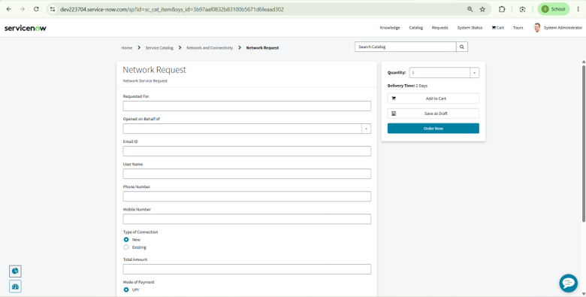
Figure 2. Service Portal Network Request form. This is the requester-facing ServiceNow catalog interface.
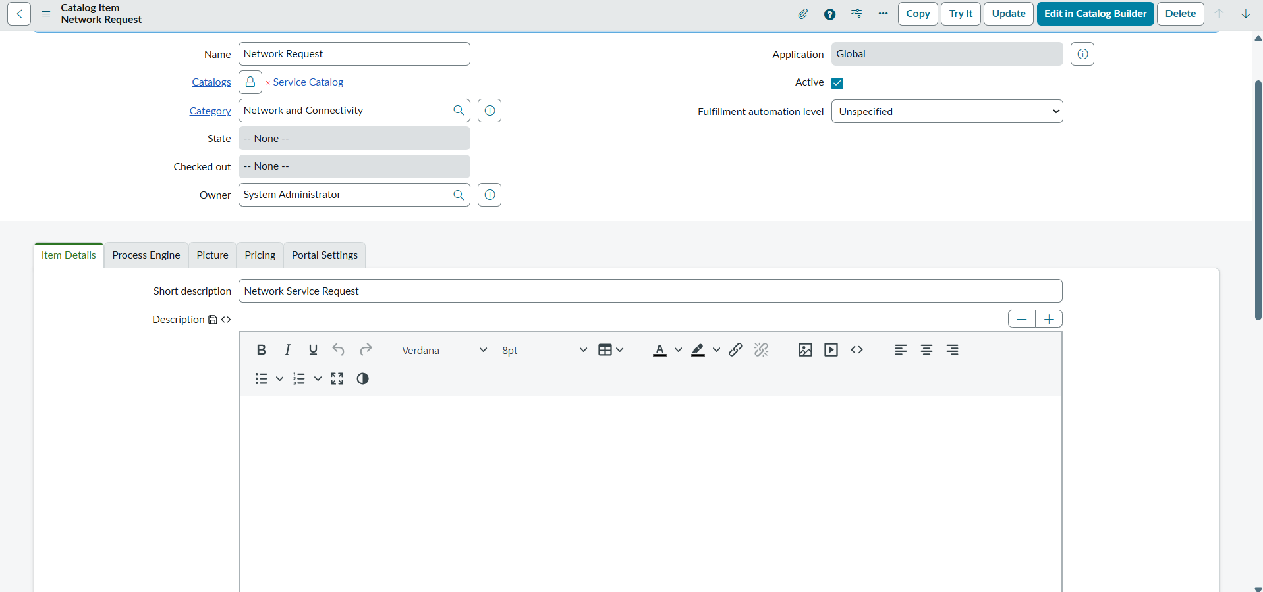
Figure 3. Network Request catalog item configuration, including the catalog item name, category, and item details.
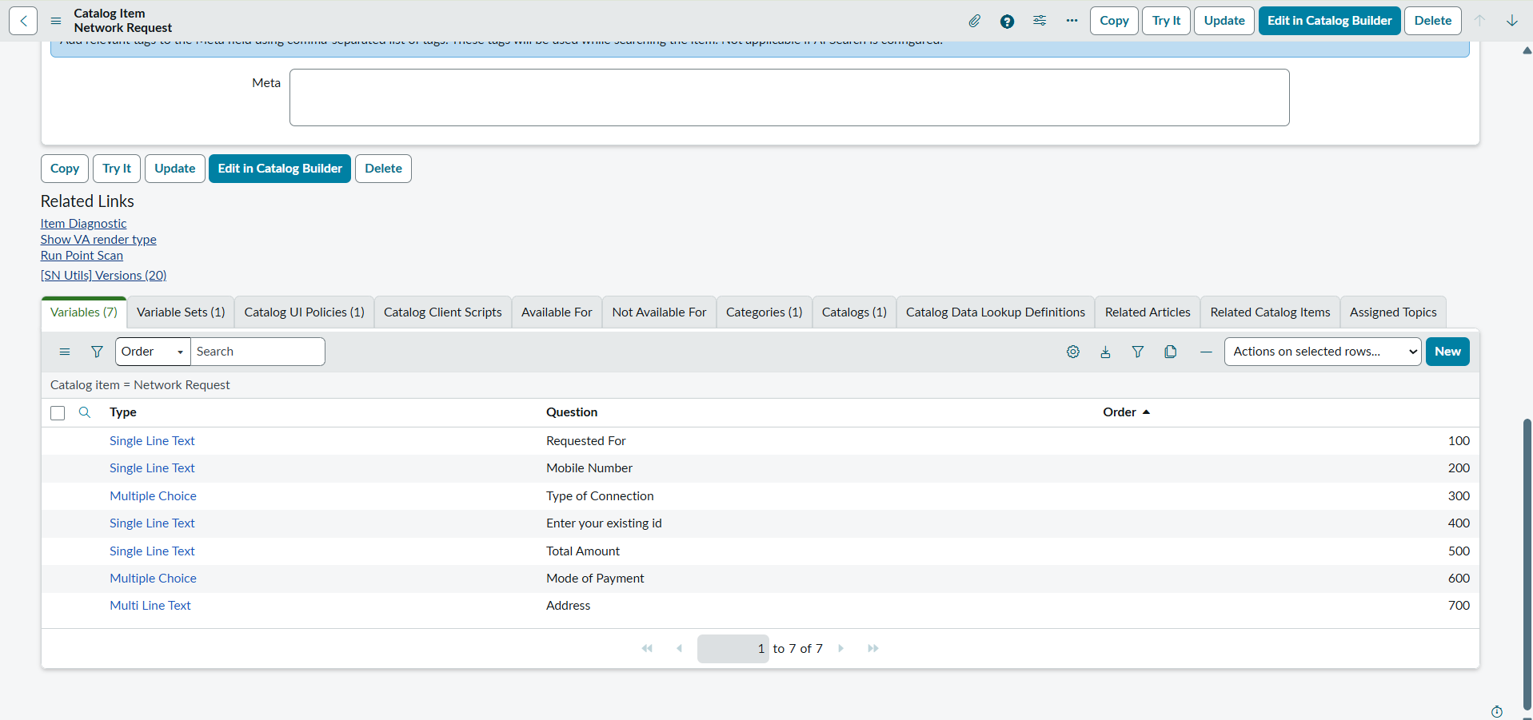
Figure 4. Catalog item variable list showing the seven request variables and their order.
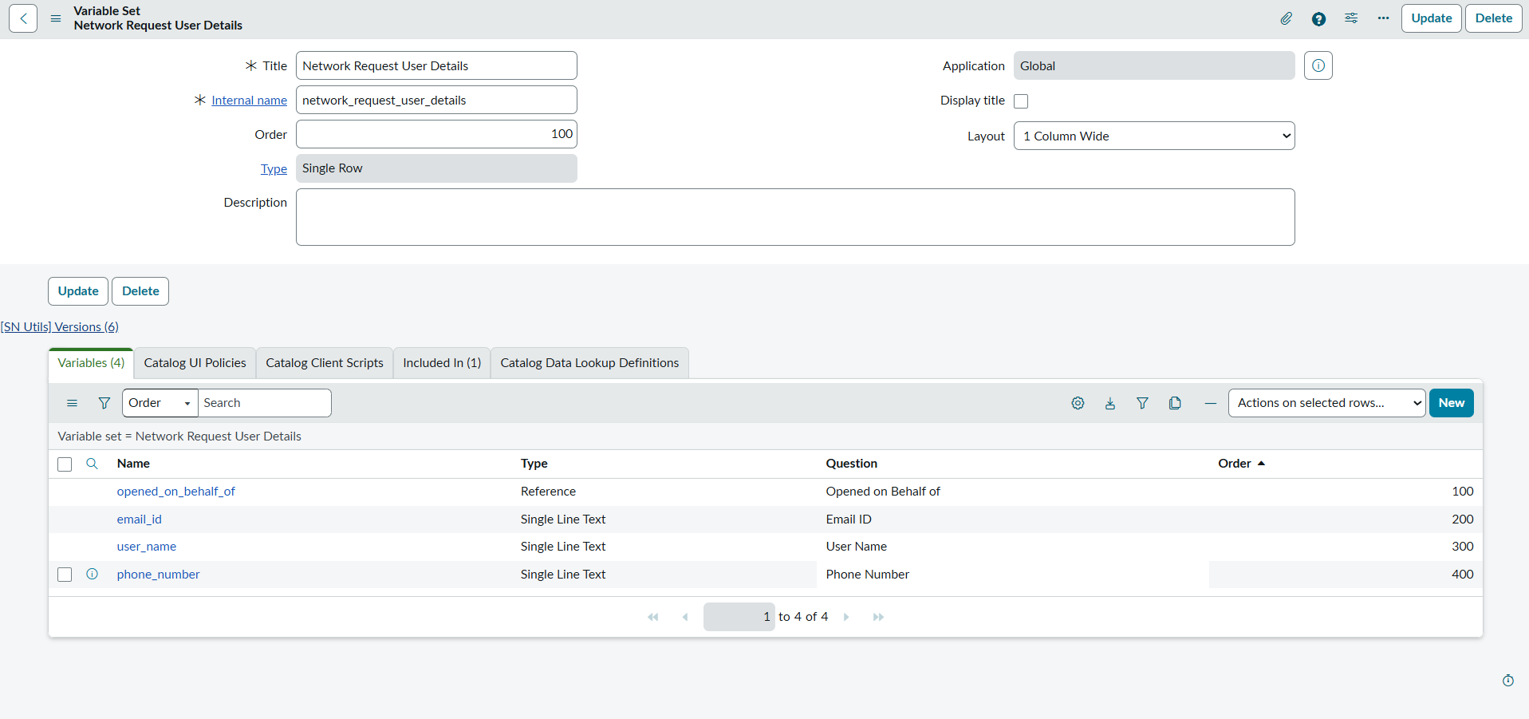
Figure 5. Network Request User Details variable set and its common user-detail variables.
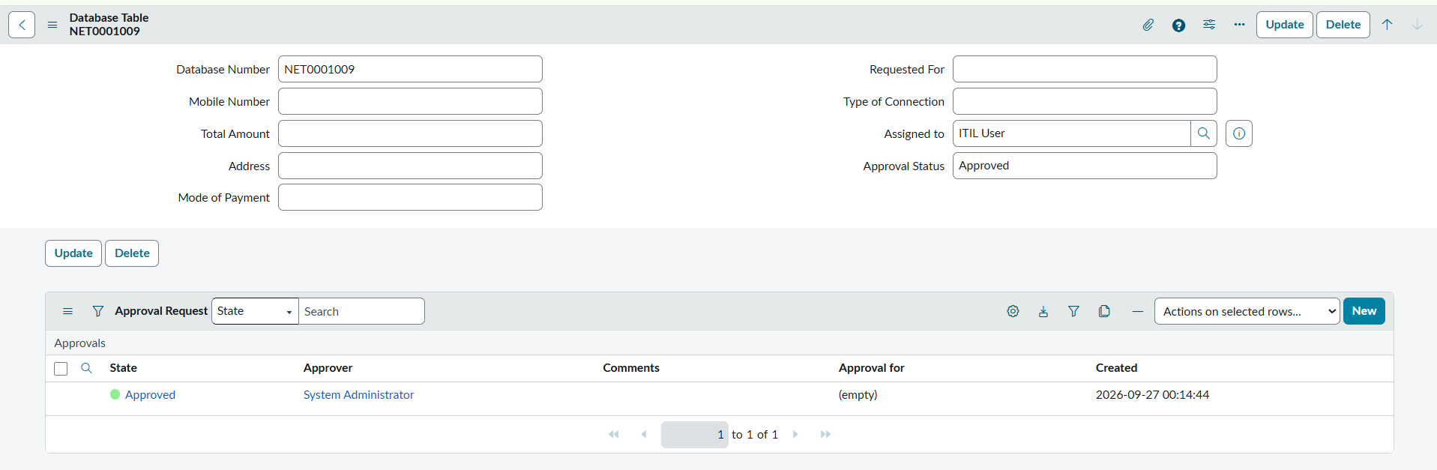
Figure 6. Catalog UI Policy configuration for showing the existing-ID field when Type of Connection is Existing.
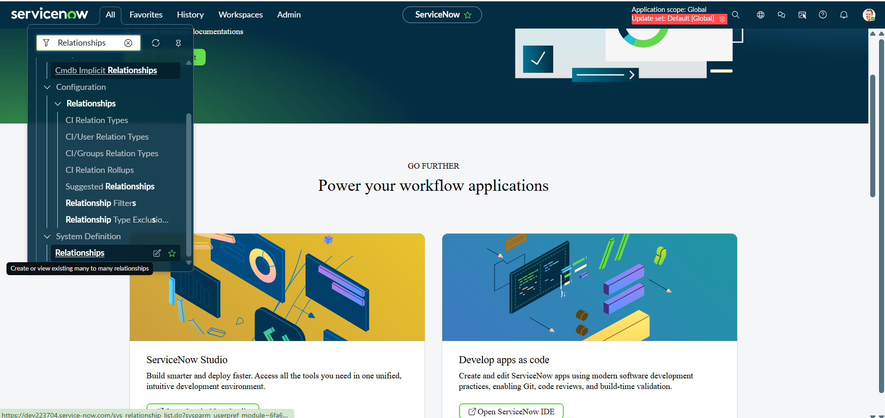
Figure 7. Custom Database Table dictionary configuration showing the project-specific fields and standard system fields.
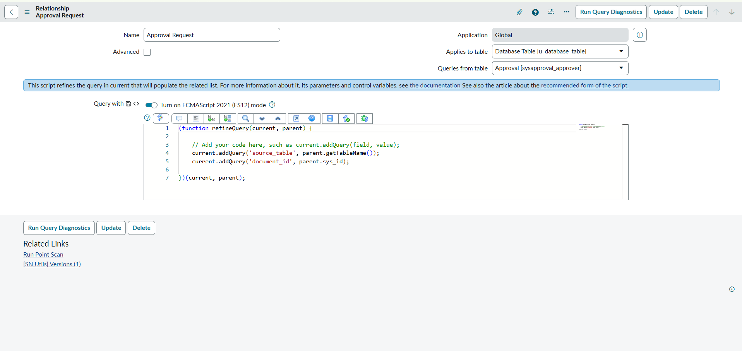
Figure 8. Approval Request relationship configuration connecting approval records to the custom Database Table.
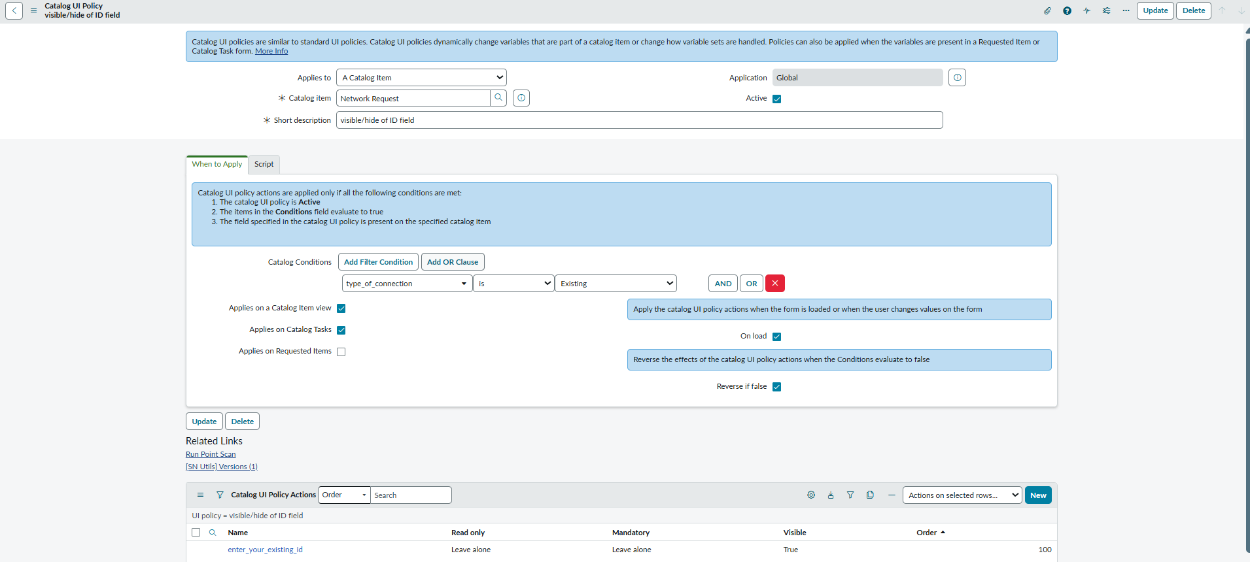
Figure 9. Active Network Request Flow Designer flow: catalog trigger, variable retrieval, record creation, email, approval, and conditional update actions.
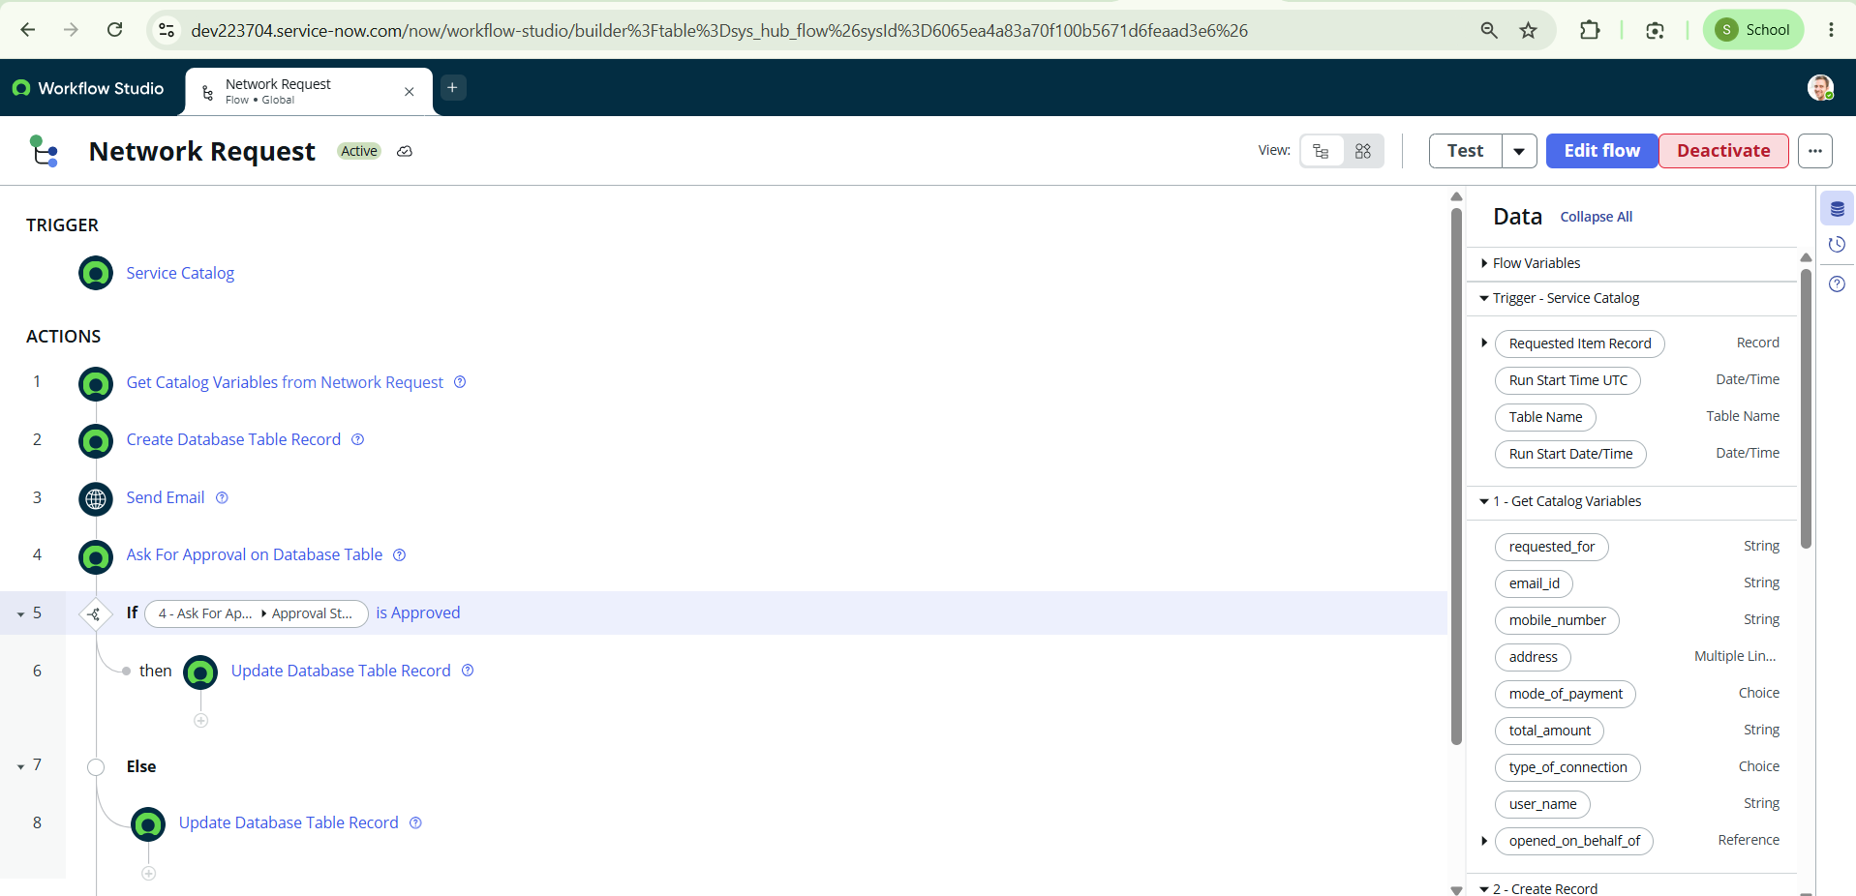
Figure 10. Network Request flow showing the approval condition and the approved/alternate update branches.
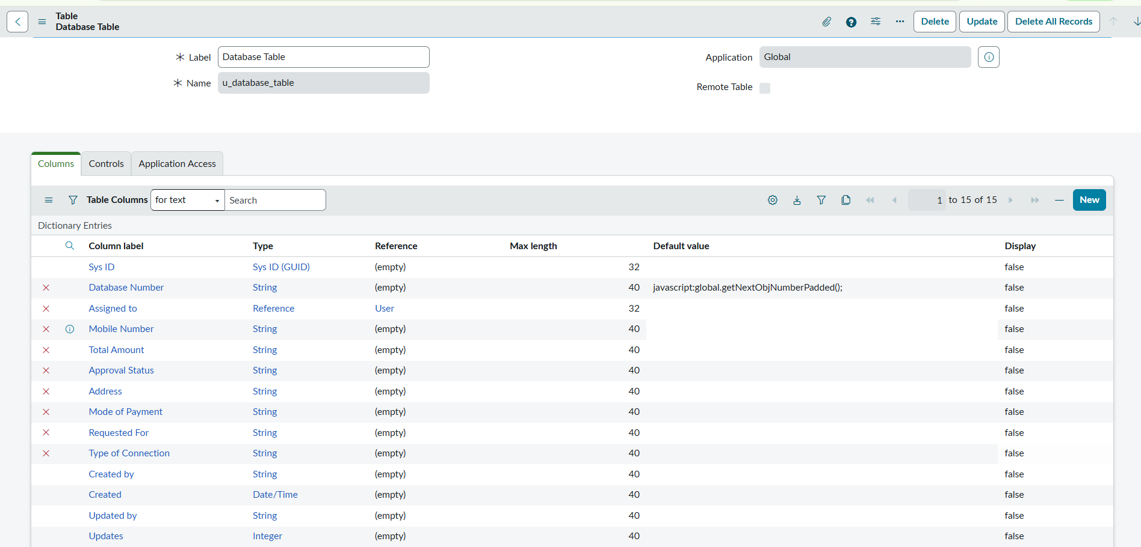
Figure 11. Request-created email preview confirming the request reference and providing a View request link.
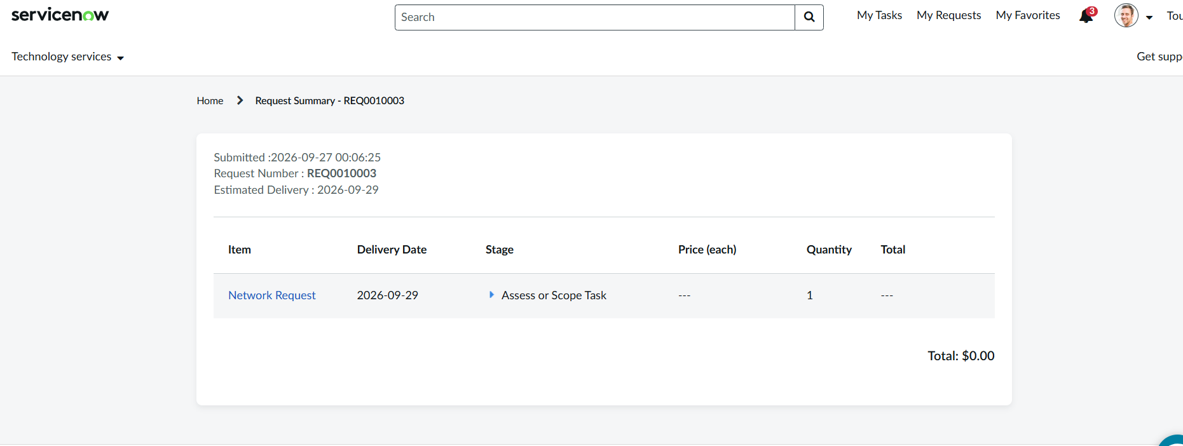
Figure 12. Request Summary showing the request number, estimated delivery date, item, and current fulfillment stage.
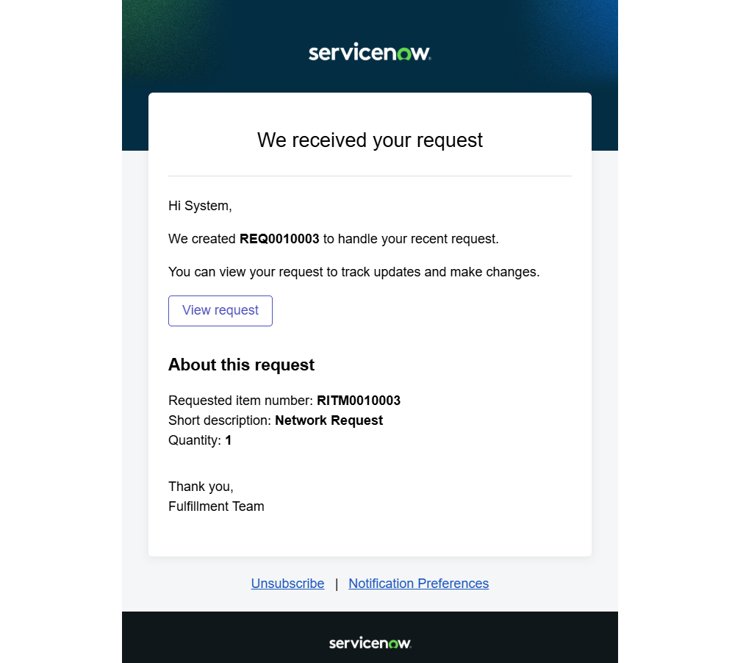
Figure 13. Custom Database Table record showing the generated database number, assigned user, approval status, and related approval record.

11. Benefits and Client Value

11.1 Operational benefits
- Standardized intake: the catalog form guides requesters to provide information in a consistent structure.
- Reduced manual coordination: Flow Designer connects record creation, notification, and approval in one process.
- Improved traceability: request records, custom-table records, approvals, and catalog tasks provide separate but related evidence of the request lifecycle.
- Faster communication: the confirmation email gives the requester a reference number and a route back to the request.
- More relevant data entry: conditional visibility avoids showing the existing-ID field for every request.
- Easier administration: ServiceNow-native configuration can be maintained in the platform without operating a separate application stack.

11.2 How a client could use it
An IT service desk or network operations team could adapt this pattern for requests such as a new network connection, an existing connection change, or a connectivity-related service request. The organization would tailor the request fields, approval rules, assignment groups, fulfillment tasks, access controls, and notifications to its internal network-change policy.
The value is not that ServiceNow performs the physical network configuration automatically by itself. The demonstrated project automates the request-management workflow around the change. Actual device configuration or access provisioning would require a connected fulfillment procedure, integration, or network-engineering action if that capability is needed.

12. Limitations and Known Considerations
- The custom table fields shown in the screenshots store several values as String. Production deployments should use suitable field types, validation, and reference fields where appropriate.
- The screenshots show the custom table Approval Status field and the standard request fulfillment Stage separately. These values serve different purposes and should be mapped intentionally.
- The email screenshot uses admin@example.com as a test recipient. Production notification recipients should be configured for the actual requester and/or operational group.
- The exact rejection-state value and the field updates on the alternate branch should be confirmed from the flow action configuration and tested.
- The project description mentions group/role configuration, SLA compliance, dashboards, and network-task assignment. The evidence included here does not fully demonstrate ACLs, SLA definitions, dashboard widgets, or automated device provisioning. These should not be represented as verified capabilities unless configured and tested.
- A custom table name visible in the screenshots is u_database_table. If the implementation later renames it or uses a different table, update the documentation to match the final instance.

13. Future Enhancements
- Implement approval routing rules based on connection type, risk, urgency, department, and business justification.
- Configure dedicated requester, approver, network-team, and administrator roles with tested ACLs and least-privilege access.
- Use choice, reference, date/time, currency, and phone field types where appropriate rather than storing every value as a string.
- Add data validation for mandatory fields, phone/email formats, amount values, and existing-connection identifiers.
- Configure assignment groups and task routing so approved requests create or update the appropriate fulfillment tasks automatically.
- Define SLAs for approval time and fulfillment time, and expose compliance metrics in reports or dashboards.
- Add notifications for approval requested, approved, rejected, work started, work completed, and overdue requests.
- Record clear rejection reasons and provide a resubmission path for rejected requests.
- Integrate with network inventory or configuration systems if the organization requires automated provisioning or configuration changes.
- Add test cases and execution evidence for both approval branches, missing/invalid input, notification failures, and task completion.

14. Conclusion
The Automated Network Request Management System demonstrates how ServiceNow can be configured to manage a network-service request from catalog submission through record creation, notification, approval, and approval-based record updates. The solution uses platform-native components—Service Catalog, catalog variables, a variable set, Catalog UI Policy, a custom table, Flow Designer, approval records, and email notifications—rather than a separate web application stack.
The supplied evidence shows the central workflow and its supporting records. For a client-ready production rollout, the next priorities are to validate both approval outcomes, confirm all field mappings, configure least-privilege access and production recipients, and add SLA/reporting or network-system integrations only where required by the operating environment.

